Title: How to install and enable Java plugins on a Mac OS X
Category: Operations Support
Created By: Jacob Pacheco, IT Assistant Director
Version: 1.0
Created on: 04/24/2013
Last Modified: 04/24/2013
Objective: This document will provide guidance on installing and configuring Java plugins for Mac OS.

Affected System(s):
- OS X 10.8, 10.7 10.6

Affected Department(s):
- Agency Employees and Hiring Managers

Procedures
- Mac OS X 10.7 – 10.8
  - http://support.apple.com/kb/HT1338
    - From the Apple () menu, choose Software Update.
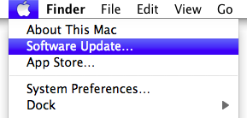
    - Software Update checks for available updates. In the Software Update window, select the items you want to install, then click Install. Usually, you should install all available updates.
    - Enter an administrator account name and password.
    - After installation is complete, restart the computer if required.
  - http://support.apple.com/kb/HT5559
- Open Terminal, located in the Utilities folder.
- Enter this command, then press the Return or Enter key:
sudo mkdir -p /Library/Internet\ Plug-Ins/disabled
- Enter this command, then press the Return or Enter key:
sudo mv /Library/Internet\ Plug-Ins/JavaAppletPlugin.plugin /Library/Internet\ Plug-Ins/disabled
- Enter this command, then press the Return or Enter key:
sudo ln -sf /System/Library/Java/Support/Deploy.bundle/Contents/Resources/JavaPlugin2_NPAPI.plugin /Library/Internet\ Plug-Ins/JavaAppletPlugin.plugin
- To re-enable Java SE 6 Web Start, enter this command, then press the Return or Enter key:
sudo ln -sf /System/Library/Frameworks/JavaVM.framework/Commands/javaws /usr/bin/javaws
  - Download and Install preferred browser
    - Chrome:
      - https://www.google.com/intl/en/chrome/browser/
    - Firefox:
      - http://www.mozilla.org/en-US/firefox/new/
- Mac OS X 10.6
  - http://support.apple.com/kb/HT1338
    - From the Apple () menu, choose Software Update.
    - Software Update checks for available updates. In the Software Update window, select the items you want to install, then click Install. Usually, you should install all available updates.
    - Enter an administrator account name and password.
    - After installation is complete, restart the computer if required.
  - Download and Install preferred browser (Safari will not work)
    - Chrome:
      - https://www.google.com/intl/en/chrome/browser/
    - Firefox:
      - http://www.mozilla.org/en-US/firefox/new/
  - Talent Acquisition
    - Go to https://ltm.azdoa.gov
      - Download and install Java if prompted.
      - If prompted to allow Java click yes and always allow.

      - Chrome - Click here if this page does not load within 5 seconds
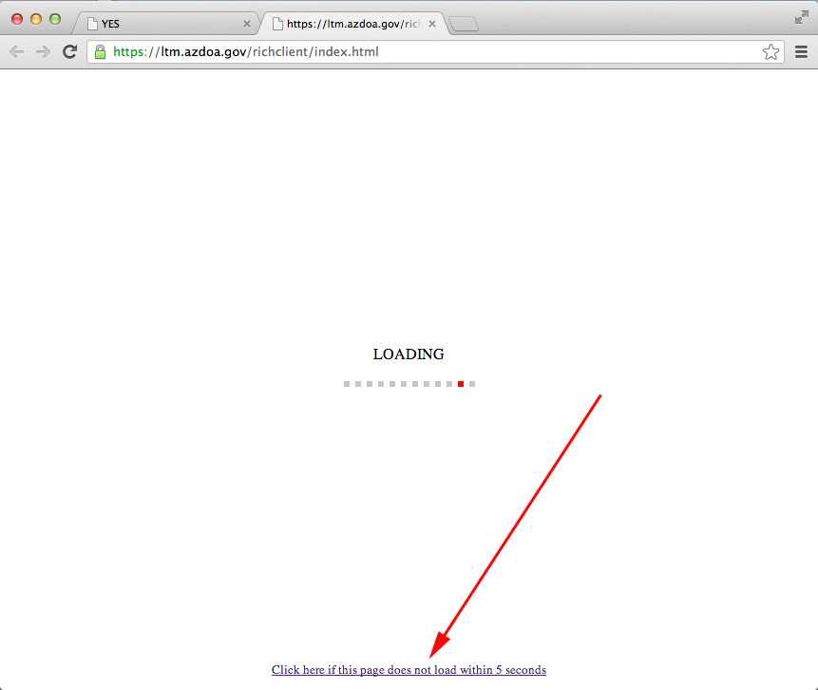

References

